**UPDATED RESUME**

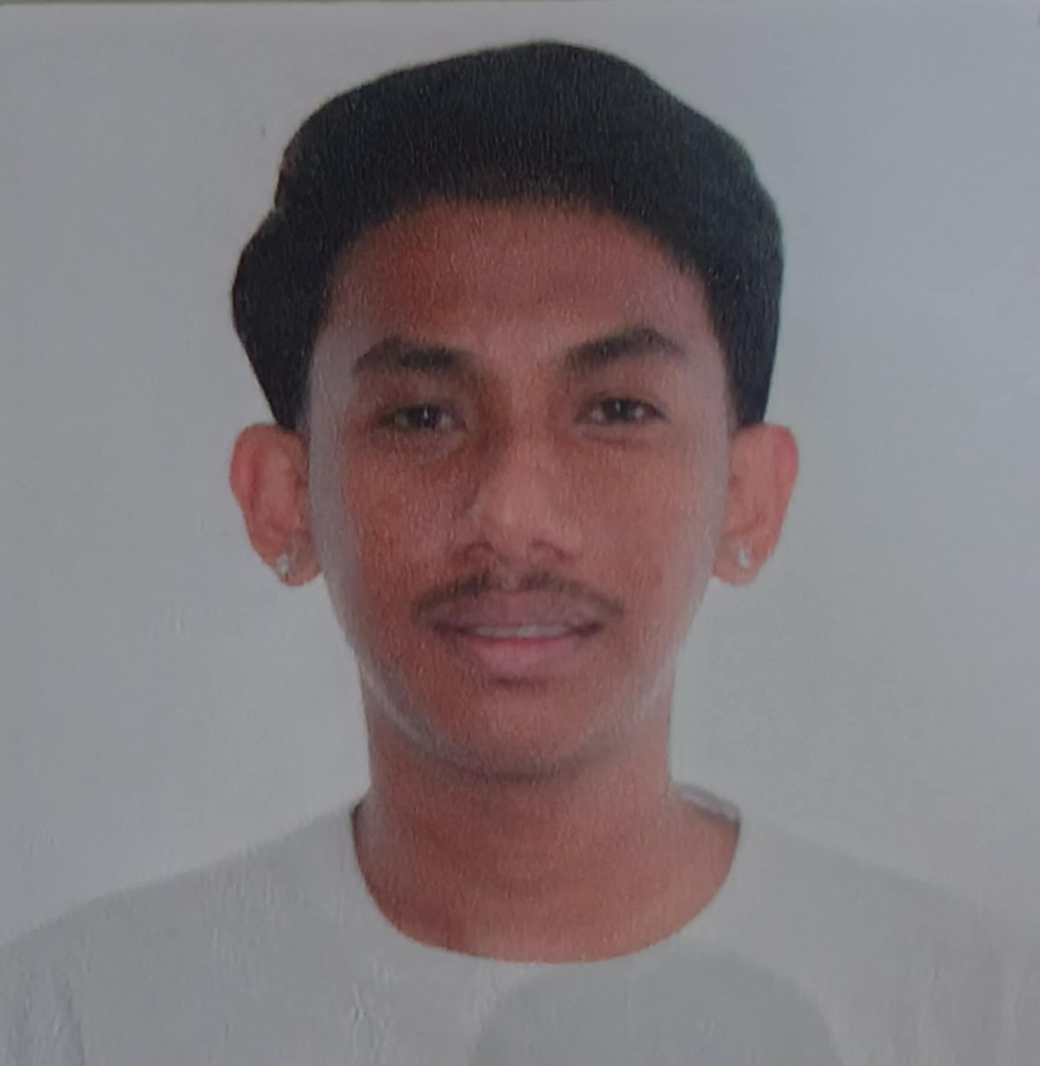

**Name (Last, First, M.I.): Tugdang, Aljhon Cabual.**

**Address: Saint Jude St 3rd Ave, Brgy Fatima 4, CSJDM, Bulacan**

**Contact No: 09461383561**

**Email Address: aljhontugdang79@gmail.com**

**PROFESSIONAL EXPERIENCE**

|  |  |  |  |
| --- | --- | --- | --- |
| **COMPANY** |  | **POSITION** | **DURATION** |
|  |  |  |  |
|  |  |  |  |
|  |  |  |  |

**EDUCATIONAL BACKGROUND**

|  |  |  |
| --- | --- | --- |
| **GRADUATE SCHOOL** | | |
| **SCHOOL** | **COURSE** | **DURATION** |
| BESTLINK COLLEGE OF THE PHILIPPINES | BACHELOR OF SCIENCE IN INFORMATION SYSTEM | 2021-2025 |
|  |  |  |
| **COLLEGE/BACCALAUREATE** | | |
| **SCHOOL** | **COURSE** | **DURATION** |
| SAN JOSE DEL MONTE NATIONAL TRADE SCHOOL | TECHNICAL-VOCATIONAL LIVELIHOOD TRACK SHIELDED METAL ARC WELDING STRAND | 2019-2021 |
|  |  |  |
| **SECONDARY** | | |
| **SCHOOL** | **COURSE** | **DURATION** |
| SAN JOSE DEL MONTE NATIONAL TRADE SCHOOL | JUNIOR HIGH SCHOOL | 2014-2019 |
| **ELEMENTARY** | | |
| **SCHOOL** | **COURSE** | **DURATION** |
| SAPANG PALAY PROPER ELEMENTARY SCHOOL | ELEMENTARY | 2009-2014 |

**SEMINARS AND TRAININGS ATTENDED (*2018 up to present*)**

|  |  |  |
| --- | --- | --- |
| **TITLE/TOPIC** | **LOCATION** | **DURATION** |
|  |  |  |
|  |  |  |

**PERSONAL INFORMATION**

|  |  |
| --- | --- |
| Date of Birth: | OCTOBER 21, 2002 |
| Place of Birth: | BAGONGBONG, CALOOCAN |
| Age: | 22 |
| Status: | SINGLE |
| Height: | 5’7 |
| Weight: | 52 |
| Mothers Name: | ALFREDA C. TUGDANG |
| Fathers Name: | DIONNIE G. TUGDANG |
| Spouse Name: | NONE |
| Occupation: | STUDENT |
| No. of Dependents: |  |

|  |  |
| --- | --- |
| **CHARACTER REFERENCES NAME** | **CP NUMBER/ADDRESS** |
| ALFREDA TUGDANG | 09461383561 |

_______________________ Date Accomplished:

Signature over Printed Name